Camping Handbook
A Guide for
Parents

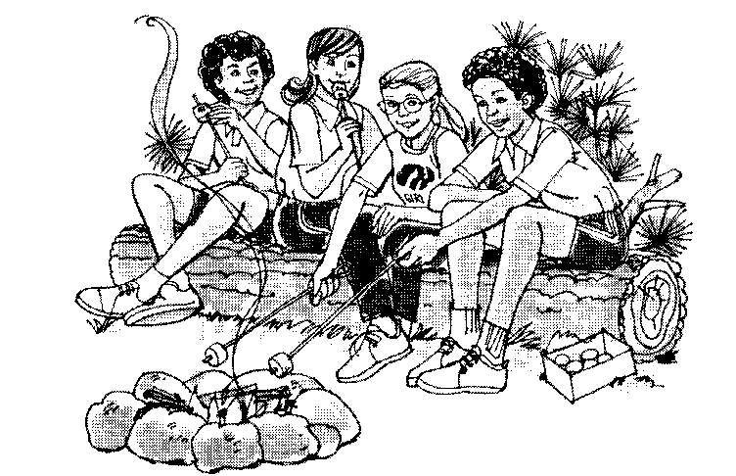

Introduction
The Girl Scout Outdoor program is intended to help girls develop various skills. Camping helps girls develop to their full potential by providing a means for them to learn how to be independent. We will learn about protecting our environment, working together as a team, taking care of ourselves, and to have fun in any circumstances. The purpose of this handbook is to inform parents of our procedures at camp, and to enable them to prepare their daughters for the outdoor experience. Girl Scouting is filled with special words – see the glossary at the end of the handbook for the meaning of words marked with an asterisk (*).

Preparing for Camp
We have spent several of our meetings preparing for camp. But you know your daughter best. The following is a list of skills your daughter should be able to perform prior to the camping trip. Please practice these skills prior to our trip.

- Responsible for own belongings
- Ability to choose appropriate clothing for the weather (see clothing section)
- Ability to perform personal grooming tasks
- Pack own bags
- Roll own bedroll*/sleeping bag and secure it
- Carry own belongings (sleeping bag and duffel bag)
- Slept away from parents for at least two nights
- Can work with other girls that are not her best friends
- Can follow directions
- Can be flexible
- Will try new things
- Stir a pot of cooking food
- Use a knife to cut food
- Wash personal dishes (see dishwashing section)
- Clean a toilet and sink
- Wipe tables
- Use a potato peeler
- Use a manual can opener
- Sweep floors

Camp Life
Living in camp is fun! Girls will enjoy doing many of the tasks they groan at doing at home. They’ll have fun keeping the lodge clean, making dinner, and washing dishes

- Dish Washing
Each girl is responsible for washing her own personal dishes. A dunk bag* is a mesh bag – lingerie bag will work fine, or you can sew together two open weave dishtowels on three sides and weave a string through the top. All dunk bags must have a draw string along the top. Dishes should be unbreakable – use old dishes – Character type dishes work great. You should have a plate and a bowl along with a fork, spoon and knife. Cups should be non-metal and should have a handle – we drink hot chocolate in them as well as cold beverages.

- Kapers*
Each girl will have specific chores to perform during camp. These include cooking, fire building, cleaning the lodge and latrines. Your daughter needs to learn the importance of working with others – even if they are not best friends. Girls work in patrols* under the supervision of two adults.

- Safety
Your daughter’s safety is very important to Girl Scouts. We will follow all Safety Wise* policies while on our trip. You may check this book out of the troop library at any time for your reference.

We observe the “buddy system*” at camp at all times. This means girls are to go no where without a friend with them. We will have assigned buddies and girls are to stay with their assigned buddy for the entire trip.

We will have a fire drill at camp and the girls will practice where to meet if there is an emergency. In addition we have gone over what to do in case someone is lost or if there is bad weather.

We have two qualified First Aiders* at camp at all time. Medication will only be administered by a First Aider. Any event that requires anything more than minor first aid we will call a parent. All medication must be in the original container and labeled with the girl’s name. Written permission must be provided. This applies to all medications, including non-prescription.

- Clothing
Let your daughter pack her own clothes. That way she will know what was packed and where it is. But help her make appropriate choices for the weather. A few things that are not allowed – sandals, shoes without backs (old comfortable tennis shoes are best);

Girls will wear closed toe shoes at all times in camp. During the day she should wear socks with comfortable walking shoes (we do a lot of walking!). At night, if she needs to go to the latrine*, she will need to put her closed toe shoes back on. If she wishes, she may bring a pair of waterproof “flip flops” for the shower. But they may only be worn while in the shower! All other times closed toe shoes with backs must be worn.

It will probably be cool in the mornings, warm in the afternoons and cold at night – therefor your daughter should dress in layers and bring a jacket.

Before going to bed your daughter will need to change all clothing, including socks and underwear so that they will stay warm at night.

Girl’s heads will need to be covered by either a hat or a bandana. We will provide a color-coded bandana for each member of a patrol. This bandana must be worn during the day so that we can easily identify which patrol she belongs in. She may however, wear a hat as well. If she does bring a hat, it must cover her head – ie, no visors.

- Sleeping
We will sleep in cabins – 4 to a cabin. Girls do not sleep in the same cabin with adults. These cabins have electric lights, but no other electricity. Cabins are assigned and girls may not change unless directed to do so by an adult. Your daughter needs to bring a sleeping bag or bedroll* and a pillow. Do not bring “slumber bags” – they are not warm enough! The temperature rating should be 40° or lower. Girls are encouraged to bring a stuffed animal or other sleeping buddy. Lights out is 11:00pm – but quiet time begins at 10:00pm.

- Behavior
Girls are expected to live by the Girl Scout law while at camp. Any girl whose behavior puts the safety of girls at risk will be asked to leave and her parents contacted for pick up.

We have many fun activities planned, but if girls are disruptive to the point that other girls are affected by their behavior they will be asked to find another activity.

- Lost and Found
We expect all girls to be responsible for their own actions and belongings. We have a tradition that if a girl leaves her belongings unattended in public areas, she must recite the GS Law to a leader in private in order to get her belongings back. Before we leave camp we will have one more time for all girls to claim their belongings (without having to say the law). If there are any unclaimed items we will have a bag available for parents to check when picking up their daughters. Anything not claimed that day will be sent to Goodwill.SUGGESTED PERSONAL EQUIPMENT LIST FOR CAMPING OVERNIGHT:

(mark name on all items with permanent marker)

HEALTH AND SAFETY:
- Signed permission slip and money (collected BEFORE the trip)
- Medication: properly labeled and given to First Aider.

BASICS:
- Waterproof bag or duffel to carry gear, (suitcases are hard to pack)
- Water bottle
- Flashlight, spare batteries
- Plastic bags for wet/dirty things
- Work gloves w/o plastic nubs

SLEEPING SYSTEMS:
- Sleeping bag, bedroll (not slumber bag!)
- Pajamas (two piece), sweatsuit
- Small pillow, or just a pillow case to be stuffed with extra clothes
- Blanket
- Hat
- Clean socks and underwear
- SMALL stuffed “friend” for sleeping

EATING EQUIPMENT (Dunk Bag):
- Unbreakable bowl, plate, cup (or mess kit)
- Knife, spoon, fork (unbreakable)
- Drip (net) bag with drawstring

Turtle Time:
Book or other quiet activity that can be done on their cot.

CLOTHING:
- Wear weather-appropriate clothing
- Rain gear – poncho, suit, etc – no umbrellas!
- Jacket/sweater/sweatshirt
- Hat and/or bandana (see clothing section)

2 Changes of clothing:
- Underwear
- Jeans/long pants/shorts
- Shirt, sweatshirt, turtleneck
- Socks (Knee socks required for shorts)
- Spare shoes (NO sandals)
- One extra change of clothes

TOILET KIT:
- Toothbrush, toothpaste
- Washcloth, SMALL hand towel, small soap
- Bath Towel (light weight)
- Brush/comb
- lip balm
- Non-aerosol bug repellent
- Sun block

DO NOT BRING TO CAMP:
- Scented items
- Gum, candy or other food
- Aerosol cans
- Glass containers (except Rx given to First Aider)
- One piece PJ’s or nightgowns
- Toys, anything electronic, breakables, or anything else you can’t live without if lost.

HELPFUL HINTS:
- A girl scout who packs her own bag knows what she has and where to find it!
- The girls MUST be able to carry their own gear. Keep it light enough to handle.
- Dress in layers;
- Pack with first-used items on top;
- Shoes must be worn at all times
- Pack in waterproof duffle bag or stuff sack.

Glossary

- Bedroll – Instead of a sleeping bag you can use three blankets and a ground cloth over lapping to form a sleeping system.

- Buddy System – Two (or more) girls who travel everywhere together – even to the latrine!

- Dunk Bag – mesh bag in which to hold plastic dishes – Lingerie bags work especially well.

- First Aider – Adult specially trained in first aid and CPR. Only authorized person to dispense any sort of medication.

- Kaper – Girl Scout word for “chore”. We use kaper charts to keep track of who does what chore. Kapers include Cooking (which includes hostess, cook, fire builder, and clean up), Cleaning lodge, cleaning latrines, firewood gathering, and unit check-in and out.

- Latrines – Girl Scout word for bathroom. Our bathrooms are indoor modern toilets – sometimes referred to as “flushies”, but are still generally called latrines.

- Patrols – Groups of girls working together on kapers. Two adults are in charge of each patrol.

